LASER SCANNING & BIM

Scan to BIM

WHAT IS SCAN TO BIM

• Building Information Modeling (BIM) is the strategy for application of information technology to the building industry.

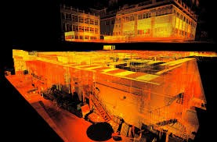

• Utilizing laser scan data to capture the as – built environment, allows faster more accurate 3D BIM model creation. Ideal for refurbishment or retro – fitting projects, scanning both external and internal builds for a high accuracy 3D survey from which the intelligent model is created.

• The application of building information modeling solutions results in higher quality work, greater speed and productivity, and lower costs for building industry professionals in the design, construction, and operation of buildings.

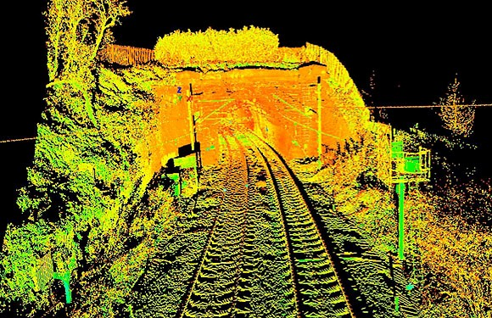

WHY SCAN TO BIM

• The implementation of BIM is fundamentally changing the way the construction industry works. Scan to BIM can provide a faster, more accurate, more comprehensive method for capturing survey data critical for refurbishment or retrofitting BIM projects.

Surveying Precision

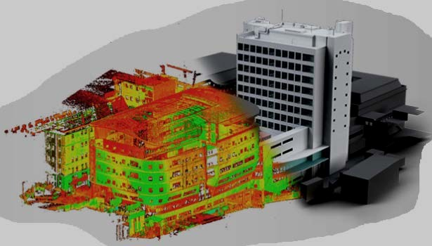

8